**To complete this activity, follow these steps:**

1. Download the [Activity 12.1](https://classroom.emeritus.org/courses/8898/files/2299984/download) folder. In a Word document, include a screenshot demonstrating that you were able to open the folder in VS Code.

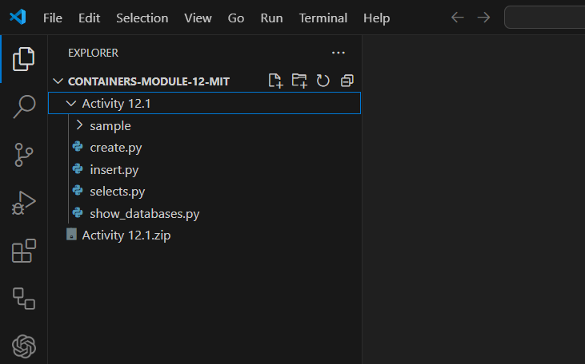

1. Open a Terminal window, navigate to the folder containing the starter file for this activity, and run the command to initialize the *driver*. Provide a screenshot demonstrating that you successfully ran the command.

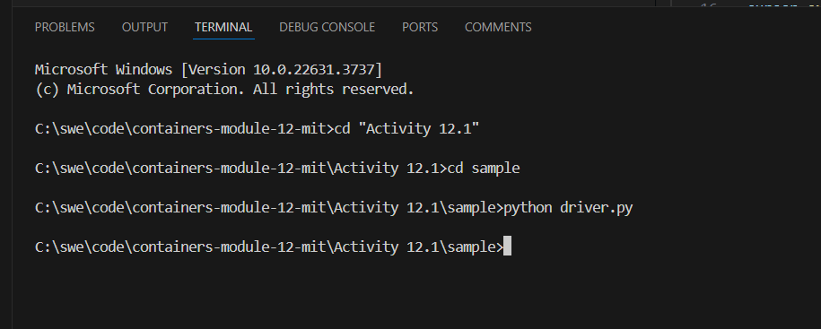

1. Show the databases available in your starter code. Ensure that the ‘information_schema’, ‘performance_schema’, ‘sys’, and ‘mysql’ databases are there and provide a screenshot.

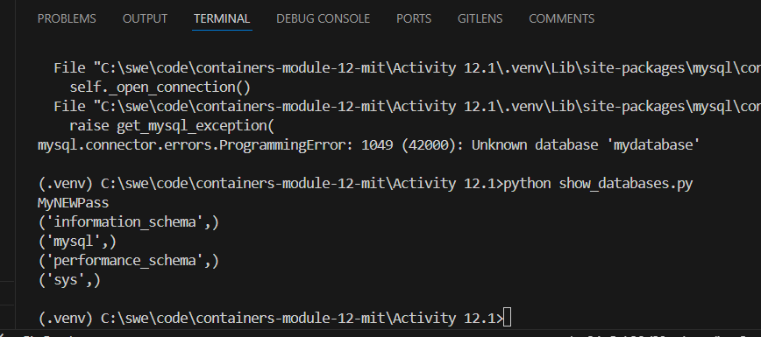

1. Open the `create.py` file and modify it to create a database called `restaurants`. This database will contain two columns both of type varchar. They will both allow a maximum of 20 characters. Provide a screenshot demonstrating that you have successfully modified the code.

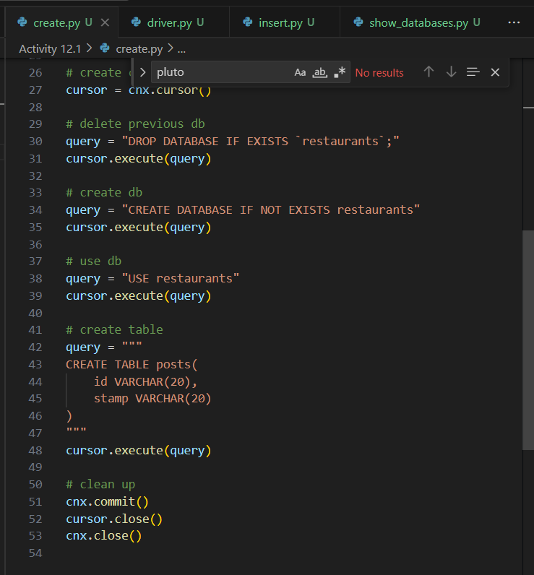

1. In the Terminal window, run the correct commands to create and visualize that the ‘restaurants’ database has been created and provide a screenshot.

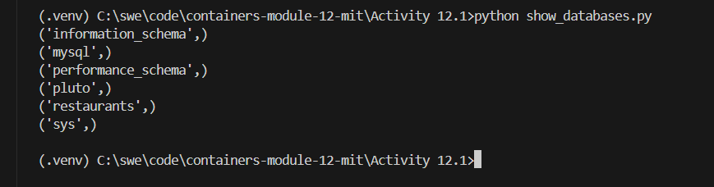

1. Modify the ‘insert.py’ file to add one restaurant with id equal to 1 and your current time and provide a screenshot of your modified code.

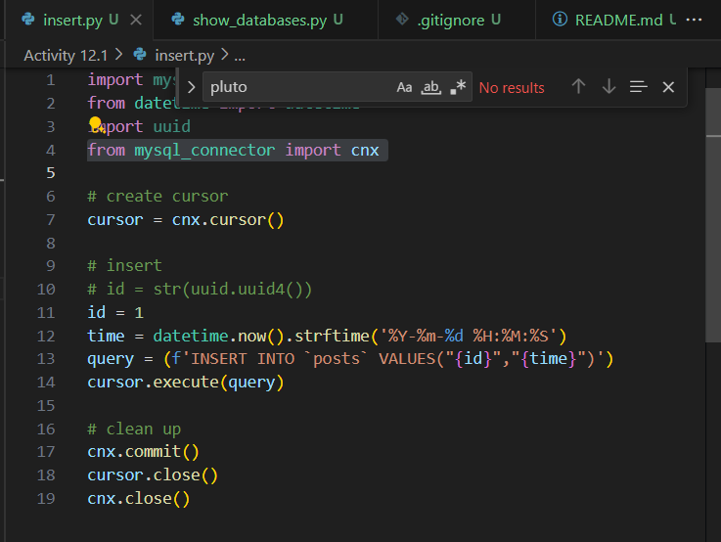

1. Insert the entry in the ‘restaurant’ database and provide a screenshot of your Terminal window after running the correct command. You should see the correct entry in the database. Include a screenshot of your Terminal window.

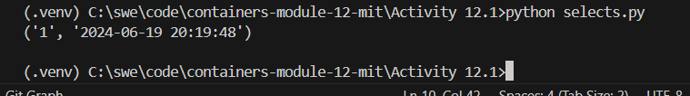

1. Following the steps in Video 12.4, create a Docker *container* named ‘my_sql’. Use port 3300. Provide a screenshot demonstrating that you successfully created the *container* in Docker.



1. Run the ‘show_databases.py’ file again while you have the Docker *container* running to show that everything runs as expected. Include a screenshot of your Terminal window. Note that your screenshot should include both the Docker *container* running as well as the Terminal window. Feel free to provide two screenshots for this step.

